**CS 307**

**Team 10**

Mihir Jham

Rishabh Mittal

Karan Kalwani

Manmohit Sehgal

Ankit Kapur

**Sprint 2 – Planning Document**

**User Stories:**

1. ***Movement Creation:***

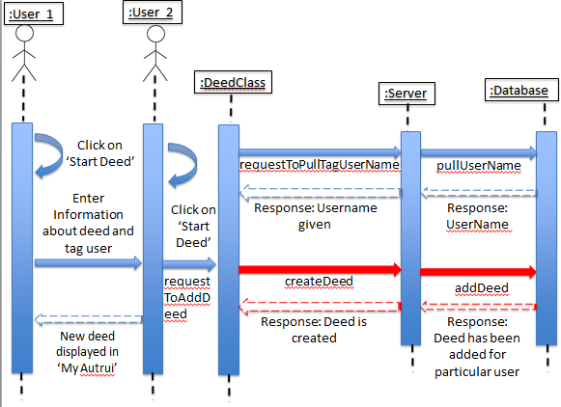

The diagram above describes the user to user interaction that essentially forms what refer to as a movement. In this case the first user starts a deed, describes and provides the information of the second user that is involved in the deed. A movement occurs when the second user basically starts a new deed paying the initial deed forward to a third user. The process repeats when every added user pays the deed forward to another user. Users can be repeated in a movement as long as they aren’t being ‘paid back’.

1. ***Movement Visualization:***

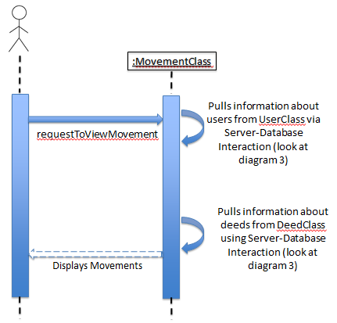

The diagram above, describes how the app responds in order to display the user the movements that he/she is part of. The user basically sends a request to view the movements. The movement class responds by doing the actions shown in diagram 3 and responds with the required information back to the user.

1. ***Social Integration:***

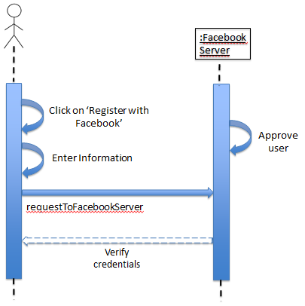

The diagram above basically explains how the app provides and implements the option for the user to register and login to the app using their Facebook account. The user essentially logs into his/her Facebook account and the respective details are then a new user is created using the information provided by Facebook. The ‘information’ here includes the name of the user, and the list of friends. This list can then be used to identify people who are already using Autrui.

1. ***Random deeds:***

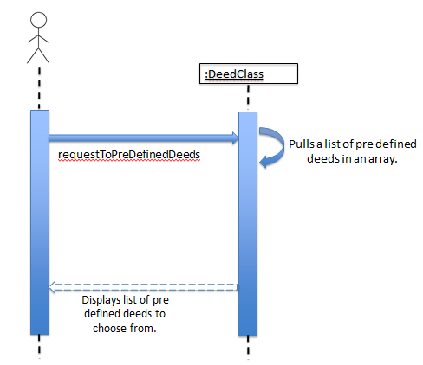

The diagram above displays what happens when the user needs ideas of new deeds that he/she can do. The user can simply look from our list of pre-defined deeds (a total of 50 till now) and simply use them to just enter the second user to connect. The deeds are stored in an array which is shown in the form of a list to the user for easy browsing and selection.

1. ***Using friends from the user’s Facebook account:***

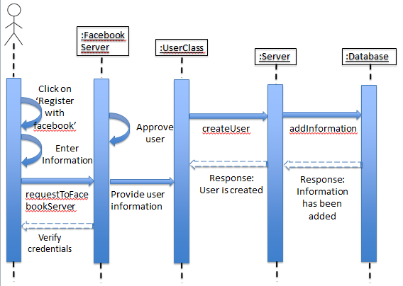

The diagram above describes how our app pulls out and uses the information that a user has on his Facebook account. The information includes details about the user that are necessary for creating an account with Autrui (i.e. full name and email id); it also includes the list of friends that the user has. Out of this list Autrui identifies the users that are already using the app and hence making it easier to tag them to deeds and being part of movements.

1. ***Push notifications:***

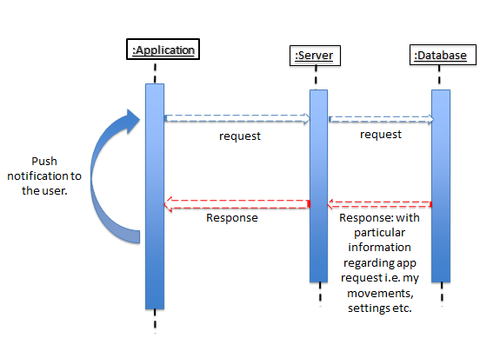

The diagram above describes the apps response to the user in the form of push notifications (when enabled) under specific situations. Scenarios like when someone has deed for the said user, or if there is an updated list of pre-defined deeds, results in the app responding with a push notification.

**Task Distribution:**

As we transition onto the second sprint of our project, we as a team have reached a stage where do not have any concrete distribution of the tasks at hand. Instead, we have a lot of tasks overlapping among all the team members as everyone is working pretty much on all parts of the project. This is specially highlighted in terms of getting the user interface up to the mark and fixing bugs, as they will not be held back to be completed by someone in particular. The table below highlights how the tasks will be divided in general:

|  |  |  |
| --- | --- | --- |
| **#** | **Task** | **Task Owner(s)** |
| **1.** | ***Movement creation:*** Until now we have been successful in creating deeds and connecting the users with their respective deeds. The next objective is to convert these small deeds into movements and be able to add a ‘tree’ of users to multiple deeds forming a ‘movement’. | Mihir Jham, Manmohit Sehgal & Ankit Kapur.  Estimated time: 20-25 hours |
| **2.** | ***Social Integration:*** As part of sprint 1 we were able to make sure that the user is able to register and create a new account and log in. We aim to also offer the option to register and log in to Autrui using the users’ Facebook account as a credential. | Mihir Jham, Manmohit Sehgal & Ankit Kapur.  Estimated time: 10 hours |
| **3.** | ***Movement visualization:*** Once the algorithm of linking multiple users to multiple deeds that are initiated by a single deed is complete, we have to work on creating a visualization that the user can understand. We aim to make something along the lines of a tree diagram that shows how one’s deed created a domino effect of deeds as every user paid the deed forward. | Mihir Jham, Manmohit Sehgal & Ankit Kapur.  Estimated time: 25-30 hours |
| **4.** | ***Random deeds:*** As part of the first sprint, we created a list of 50 pre-defined deeds. The task at hand now is to enable the user to make use of these deeds. The user should be able to view the deeds, select the one he/she likes, and able to use it to tag another user. | Mihir Jham, Manmohit Sehgal & Ankit Kapur.  Estimated time: 15 hours |
| **5.** | ***Making use of social integration:*** Once the social integration with Facebook is set up, we have to make sure that we can make use of the advantages it offers. We need to be able to access the list of friends the user has on his/her profile. | Mihir Jham, Rishabh Mittal & Ankit Kapur.  Estimated time: 15 hours |
| **6.** | ***Push notification:*** The idea is to provide notifications to the user regarding specific actions occurring in the app. Things like when the user is added to a movement, or when the list of predefined deeds is updated the user should receive a push notification. | Mihir Jham, Manmohit Sehgal & Karan Kalwani.  Estimated time: 15 hours |
| **7.** | ***Improving the user interface:*** Our app right now carries a utility outlook, which needs to change as we progress towards completion. We need to make sure it is appealing to the users. It should have warm and welcoming colors and attractive buttons. A better icon and a much improved welcome screen are also on the cards. | Rishabh Mittal & Karan Kalwani.  Estimated time: 15 - 20 hours |
| **8.** | ***Bug fixes:*** The app currently has a few bugs and glitches that need to be taken care of. We understand that we will face many such situations and will need to address them as when they arise and not keep them for the end as they can derail the app as a whole. | All. |
| **9.** | ***Weekly meetings:*** We found our initiative to meet on a weekly to be an effective measure to have the app successfully address all the criteria we had for the first sprint. We aim to continue doing so this time too. | All.  Estimated time: 10-12 hours per week. |